BRAIN TUMOR DETECTION

Application Development Report Submitted
In partial fulfillment of the requirements for the award of the degree of

Bachelor of Technology
in
Computer Science and Engineering

By

PYLA THRISHA 22N31A05K0
NAVYA MANDRA 22N31A05D3
PIYUSH SAMANTA 22N31A05H6

Under the esteemed guidance of
Ms. K. Chandusha
Assistant Professor



Department of Computer Science and Engineering
Malla Reddy College of Engineering & Technology
(Autonomous Institution- UGC, Govt. of India)

(Affiliated to JNTUH, Hyderabad, Approved by AICTE, NBA &NAAC with ‘A’ Grade)
Maisammaguda, Kompally, Dhulapally, Secunderabad – 500100
Website: www.mrcet.ac.in
2024-2025

Malla Reddy College of Engineering & Technology
(Autonomous Institution- UGC, Govt. of India)
(Affiliated to JNTUH, Hyderabad, Approved by AICTE, NBA &NAAC with ‘A’ Grade)
Maisammaguda, Kompally, Dhulapally, Secunderabad – 500100
website: www.mrcet.ac.in

CERTIFICATE

This is to certify that this is the bonafide record of the Application entitled “BRAIN TUMOR DETECTION” submitted by Pyla Thrisha (22N31A05K0), Navya Mandra (22N31A05D3) and Piyush Samanta (22N31A05H6) of B. Tech in the partial fulfillment of the requirements for the degree of Bachelor of Technology in Computer Science and Engineering, Department of CSE during the year 2023-2024.

Internal Guide Head of the Department
Ms. K. Chandusha Dr. S. Shanthi
Assistant Professor Professor

External Examiner

DECLARATION

We hereby declare that the Application titled “Brain Tumor Detection” submitted to Malla Reddy College of Engineering and Technology (UGC Autonomous), affiliated to Jawaharlal Nehru Technological University Hyderabad (JNTUH) for the award of the degree of Bachelor of Technology in Computer Science and Engineering is a result of original research carried-out in this thesis. It is further declared that the project report or any part thereof has not been previously submitted to any University or Institute for the award of degree or diploma.

Pyla Thrisha - (22N31A05K0)
Navya Mandra - (22N31A05D3)
Piyush Samanta - (22N31A05H6)

ACKNOWLEDGEMENT

We feel honored to place our warm salutation to our college Malla Reddy College of Engineering and Technology (UGC-Autonomous) for giving us opportunity to do this Application as part of our B. Tech Program. We are ever grateful to our Director Dr. V.S.K Reddy and Principal Dr. S. Srinivasa Rao who enabled us to have experience in engineering and gain profound technical knowledge.

We express our heartiest thanks to our HOD, Dr. S. Shanthi for encouraging us in every aspect of our course and helping us realize our full potential,

We would like to thank our Project Guide Ms. K. Chandusha for her regular guidance, suggestions, and constant encouragement. We are extremely grateful to our Project Coordinator Ms. D. Sai Eswari for her continuous monitoring and unflinching co-operation throughout project work.

We would also like to thank all the faculty members and supporting staff of the Department of CSE and all other departments who have been helpful directly or indirectly in making our project a success

We are extremely grateful to our parents for their blessings and prayers for the completion of our project that gave us strength to do our project.

With regards and gratitude

Pyla Thrisha - 22N31A05K0
Navya Mandra - 22N31A05D3
Piyush Samanta - 22N31A05H6

ABSTRACT
Brain tumor detection is a critical medical challenge that necessitates accurate and timely diagnosis to improve patient outcomes. This study explores advanced methods for brain tumor detection using machine learning techniques. We employed a comprehensive dataset of MRI scans and applied convolutional neural networks (CNNs) to enhance detection accuracy. The proposed model was trained and validated using extensive data augmentation and preprocessing techniques to handle the variability in MRI scans.
Our results demonstrate a significant improvement in tumor detection accuracy compared to traditional methods, highlighting the potential of AI-driven approaches in clinical diagnostics. Furthermore, the model's performance was evaluated using various metrics such as precision, recall, and F1-score, showcasing its robustness and reliability. This research contributes to the growing field of medical imaging and offers a promising tool for early and accurate brain tumor detection.
Keywords: Machine learning, MRI scans, Convolutional Neural Networks (CNN), Medical Imaging, Clinical diagnostics, AI-driven approaches, Data Augmentation.

TABLE OF CONTENTS

S. NO | TITLE | PAGE.
 |  | NO
1 | INTRODUCTION | 1
 | 1.1 PURPOSE AND OBJECTIVES | 2
 | 1.2 EXISTING AND PROPOSED SYSTEM | 3
 | 1.3 SCOPE OF PROJECT | 5
2 | LITERATURE SURVEY | 6
3 | SYSTEM ANALYSIS | 8
 | 3.1 HARDWARE AND SOFTWARE REQUIREMENTS | 8
4 | SYSTEM DESIGN | 9
 | 4.1 ARCHITECTURE | 9
 | 4.2 UML DIAGRAMS | 10
5 | METHODOLOGY | 20
 | 5.1 TECHNOLOGIES USED | 20
 | 5.2 MODULES DESCRIPTION | 29
6 | IMPLEMENTATION | 31
 | 6.1 SAMPLE CODE | 31
 | 6.2 OUTPUT SCREENS | 39

CONCLUSION & FUTURE SCOPE 41
- BIBILOGRAPHY 44

LIST OF FIGURES

FIGURE.NO | NAME | PG.NO
4.1.1 | System Architecture Diagram | 09
4.2.1 | Class Diagram | 10
4.2.2 | Use Case Diagram | 13
4.2.3 | Sequence Diagram | 15
4.2.4 | Activity Diagram | 18
5.1.1 | Architecture of Python | 22
5.1.2 | Working of Machine Learning | 24

CHAPTER 1
INTRODUCTION
The human body is made up of many organs and brain is the most critical and vital organ of them all. One of the common reasons for dysfunction of brain is brain tumor. A tumor is nothing but excess cells growing in an uncontrolled manner. Brain tumor cells grow in a way that they eventually take up all the nutrients meant for the healthy cells and tissues, which results in brain failure. Currently, doctors locate the position and the area of brain tumor by looking at the MR Images of the brain of the patient manually. This results in inaccurate detection of the tumor and is considered very time consuming. A Brain Cancer is very critical disease which causes deaths of many individuals. Early and accurate detection of brain tumors can significantly improve the chances of effective treatment and survival.
The brain tumor detection and classification system are available so that it can be diagnosed at early stages. Cancer classification is the most challenging tasks in clinical diagnosis. This project deals with such a system, which uses computer, based procedures to detect tumor blocks and classify the type of tumor using Convolution Neural Network Algorithm for MRI images of different patients. Different types of image processing techniques like image segmentation, image enhancement and feature extraction are used for the brain tumor detection in the MRI images of the cancer-affected patients. Detecting Brain tumor using Image Processing techniques involves the four stages is Image Pre-Processing, Image segmentation, Feature Extraction, and Classification. Image processing and neural network techniques are used for improve the performance of detecting and classifying brain tumor in MRI images. This automated approach reduces the reliance on manual analysis, saving time for medical professionals. It also provides consistent and accurate results, helping in early diagnosis and better treatment planning.

1.1 PURPOSE AND OBJECTIVES
The primary purpose of “Brain Tumor Detection” is to improve the accuracy, efficiency, and reliability of diagnosing brain tumors. Traditional methods of detecting brain tumors, such as manual analysis of MRI scans by radiologists, can be time-consuming and prone to human error. Machine learning offers a way to automate and enhance this process by leveraging algorithms that can analyze large datasets, identify patterns, and make predictions with high precision
The main objective of the brain tumor detection project using machine learning is to develop a robust and accurate model that can automatically detect and classify brain tumors from medical imaging data, such as MRI scans. Few other objectives are:
- Automated Image Analysis: Develop an ML model that can automatically detect the presence of brain tumors in medical images with high accuracy, minimizing false positives and negatives.
- Classification and Segmentation: Enable the classification of tumors into different types (e.g., benign vs. malignant) and segmentation of the tumor region, which aids in targeted treatment planning.
- Continuous Learning and Improvement: Implement models that can continuously learn from new data, improving their performance over time and staying up-to-date with the latest medical knowledge.

1.2 EXISTING AND PROPOSED SYSTEM
EXISTING SYSTEM:
The existing system of brain tumor detection primarily relies on medical imaging techniques like MRI (Magnetic Resonance Imaging) and CT (Computed Tomography) scans. These scans provide detailed images of the brain, allowing doctors to visualize any abnormal growths or tumors. In a typical process, the patient undergoes an MRI or CT scan, these images are then reviewed manually by radiologists, who look for abnormalities such as unusual masses, changes in brain structure, or areas with different contrast levels that could indicate the presence of a tumor. Radiologists use their expertise to assess the location, size, and type of tumor.
DRAWBACKS OF EXISTING SYSTEM
Manual Interpretation: Radiologists analyze brain scans by hand, which is slow and can vary depending on the doctor's experience. Fatigue or small details in the images may lead to errors, especially with difficult-to-spot tumors and lack the ability to accurately classify brain tumors by type and severity.
Time-Consuming: Manual diagnosis requires considerable time and effort from trained professionals, which can delay diagnosis and treatment.
High False Positives/Negatives: Radiologists can sometimes wrongly identify a healthy area as a tumor (false positive) or miss a tumor that’s there (false negative). False positives cause unnecessary stress and treatment, while false negatives delay needed care.
Lack of Standardization: Different hospitals and clinics use different equipment and procedures, leading to inconsistent results. This makes it harder to ensure accurate, uniform diagnoses everywhere.
PROPOSED SYSTEM:
The proposed system for brain tumor detection using MRI images involves several stages, including data collection, preprocessing, model design, training, and evaluation. The first stage involves collecting a large and diverse dataset of MRI images, which can be obtained from publicly available datasets or by collaborating with medical institutions. The dataset should be labeled to indicate normal and abnormal brain images and should contain different types and severities of brain tumors. The second stage involves preprocessing the dataset, which includes normalization, resizing, and data augmentation. These preprocessing techniques can improve the quality and quantity of the dataset, making it more suitable for training the CNN model. The third stage involves designing the CNN model, which includes selecting the appropriate number and type of convolutional, pooling, and fully connected layers. The model architecture should be optimized to balance accuracy and computational requirements while avoiding overfitting. The fourth stage involves training the CNN model on the preprocessed dataset using appropriate loss functions and optimization algorithms. The model should be trained until it achieves high accuracy, sensitivity, and specificity in identifying brain tumors in MRI images. The fifth and final stage involves evaluating the performance of the CNN model, which includes selecting appropriate evaluation metrics such as accuracy, sensitivity, specificity, and F1-score. The performance of the CNN model should also be compared with other state-of-the-art models and traditional methods of brain tumor detection to determine its effectiveness.

1.3 Scope of the Project
The scope of the brain tumor detection project using machine learning encompasses several critical phases and components, each designed to contribute to the successful development, deployment, and operation of the system. Below is a detailed outline of the project scope:
- Improved Accuracy: Our model can look at brain images from MRI or CT scans and help doctors to find tumors more accurately. Our model is trained to recognize patterns and spots that may be hard for a human to see. They can also draw clear outlines around the tumor, making it easier to see its size and shape.
- Reducing Human Workload: ML tools can automatically preprocess and analyze large amounts of imaging data, assisting radiologists by highlighting areas of concern and reducing their workload, allowing them to focus on more complex cases.
- Data Collection and Preprocessing: Collection of large datasets of brain MRI images, including both healthy and tumor-affected scans. Preprocessing of images (e.g., noise reduction, normalization) to prepare the data for training the model.
- Model Development: Selection and implementation of appropriate machine learning algorithms (e.g., Convolutional Neural Networks). Training the model on labelled datasets to learn the patterns associated with brain tumors.
- Model Testing and Validation: Testing the model on a separate validation dataset to assess its performance in detecting and classifying tumors. Fine-tuning the model based on performance metrics such as accuracy, sensitivity, specificity, and F1 score.

CHAPTER 2
LITERATURE SURVEY
Kapoor, L., & Thakur, S., et al. [1] conducted a comprehensive survey on brain tumor detection using image processing techniques, presented at the IEEE 7th International Conference on Cloud Computing, Data Science & Engineering. Their study highlights the importance of segmentation as the most crucial step in the detection of brain tumors from MRI images. By reviewing key medical image processing techniques, this paper provides valuable insights into the ongoing advancements in the field.
Gamage, P., et al. [2] presented a paper on the identification of brain tumors using image processing techniques, published on ResearchGate. The author divides the identification process into four distinct stages: pre-processing, segmentation, feature extraction, and classification. This structured approach provides a clearer understanding of how each step contributes to the overall detection process in MRI images.
Deepa, & Singh, A., et al. [3] reviewed recent advancements in brain tumor detection and segmentation from MRI images, presented at the IEEE International Conference on Computing for Sustainable Global Development. Their paper identifies automation in this field as an active area of research and outlines various MRI-based techniques used for tumor detection. This work emphasizes the growing importance of automation in improving detection accuracy and efficiency.
Shen, W., et al. [4] presented a study on the automatic detection of brain tumors using deep learning techniques, specifically convolutional neural networks (CNN). The paper highlights the effectiveness of CNN models in segmenting brain tumors from MRI images, demonstrating how these methods improve the speed and accuracy of detection compared to traditional techniques.
Saxena, S., et al. [5] proposed a hybrid method for brain tumor classification using a combination of k-means clustering and support vector machines (SVM). The study demonstrates that combining unsupervised clustering with SVM enhances the performance of brain tumor detection and improves classification accuracy in MRI images.
Hossain, M. S., et al. [6] developed a method for brain tumor segmentation and detection. This study focuses on enhancing the segmentation process, showcasing how U-Net variants improve the accuracy of tumor boundary detection in MRI images.
Zhao, X., et al. [7] explored the use of a 3D CNN for detecting and classifying brain tumors from MRI scans. The study emphasizes the importance of utilizing 3D spatial information to improve classification accuracy.
Akkus, Z., et al. [8] provided a comprehensive review of machine learning methods for brain tumor segmentation, focusing on both machine learning techniques. The review analyses the performance of different algorithms, including SVM, random forests, and CNNs, and discusses the future direction of brain tumor detection research.
Al-Jawad, et al. [9] presented a review on the use of convolutional neural networks (CNN) for brain tumor detection. The paper provides an overview of various CNN architectures employed in previous studies, offering insights into the strengths and limitations of each architecture. This review highlights the significant impact of CNN models in improving the accuracy and efficiency of brain tumor detection in medical imaging.
Quellec, G., et al. [10] proposed the BRAMSIT MRI database, which aims to provide users with a comprehensive set of benign and malignant examples of brain tumors. The study underscores the significance of data availability for developing accurate and reliable models in brain tumor detection, emphasizing how such databases are essential for further advancements in medical imaging research.
CHAPTER 3
SYSTEM ANALYSIS
A system analysis for brain tumor detection using machine learning involves a comprehensive examination of the system's requirements, design, architecture, components, and workflow to ensure its efficiency, reliability, and accuracy in detecting brain tumors from medical imaging data (e.g., MRI, CT scans).
3.1 HARDWARE AND SOFTWARE REQUIREMENTS
3.1.1 HARDWARE REQUIREMENTS
- RAM: 16 GB minimum (32 GB recommended for larger datasets)
- Processor: Intel Core i5+ / AMD Ryzen 5+
- Graphics Processing Unit (GPU): NVIDIA GTX 1060 Ti+
- Storage: SSD- Minimum 256 GB
3.1.2 SOFTWARE REQUIREMENTS
- Operating System: Windows 10+ / Ubuntu 18.04+
- Programming Language: Python
- Frameworks: TensorFlow, Django, Scikit-learn
- Libraries: OpenCV, Matplotlib, NumPy, Pandas
- Version Control: GIT
- Integrated Development Environment (IDE): Visual Studio Code
CHAPTER 4
SYSTEM DESIGN
4.1 System Architecture
The architecture diagram outlines a system for brain tumor detection using CNN and MRI scans. It begins with Data Processing, where MRI images are preprocessed and stored in a database. The Storage component holds both the preprocessed MRI images and the pre-trained model weights. The Model component, a Convolutional Neural Network (CNN), processes the preprocessed images by extracting features through convolution layers, then passes them through fully connected layers for tumor classification (tumor/no tumor). The results are presented through a User Interface, where users, such as doctors or radiologists, can upload MRI scans and receive classification predictions.
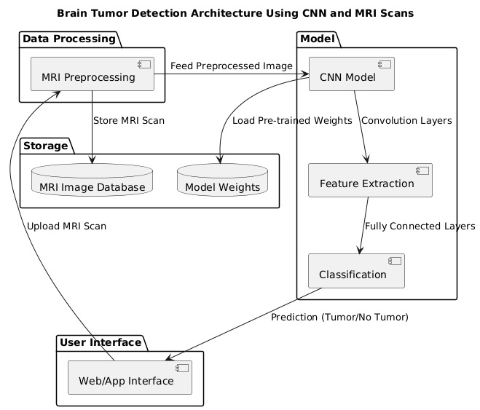 4.1.1 System Architecture Diagram

4.2 UML Diagrams
UML Diagrams are classified into different types such as:
- CLASS DIAGRAM
- USE CASE DIAGRAM
- SEQUENCE DIAGRAM
- ACTIVITY DIAGRAM
1.CLASS DIAGARM
In software engineering, a class diagram in the Unified Modeling Language is a type of static structure diagram that describes the structure of a system by showing the system's classes, their attributes, operations, and the relationships among objects. It is a representation of an object in many ways, it is simply a templet from which objects are created. Classes form the main building blocks of an object-oriented application
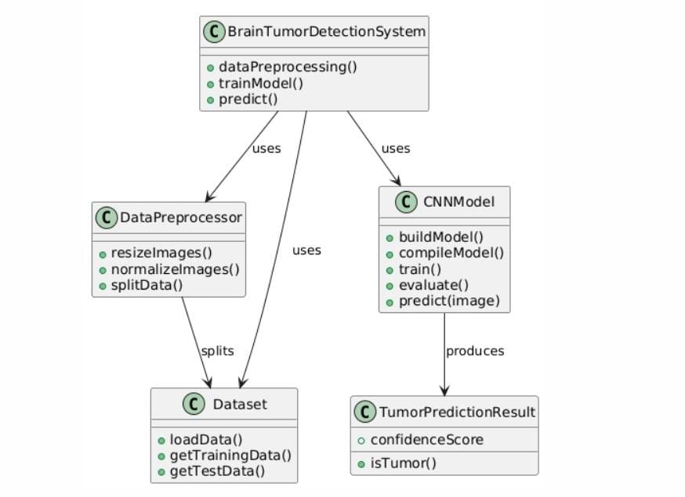
    - Class Diagram
Classes:
1. BrainTumorDetectionSystem
- Methods:
- dataPreprocessing ()
- trainModel ()
- predict ()
2. DataPreprocessor
- Methods:
- resizeImages ()
- normalizeImage ()
- splitData ()
3. Dataset
- Methods:
- loadData ()
- getTrainingData ()
- getTestData ()
4. CNNModel
- Methods:
- buildModel ()
- compileModel ()
- train ()
- evaluate ()
- predict(image)
5. TumorPredictionResult
- Methods:
- confidenceScore ()
- isTumor ()
Relationships:
1. BrainTumorDetectionSystem - Uses DataPreprocessor and CNNModel
2. DataPreprocessor- Uses Dataset (splits the data)
3. CNNModel – Uses TumorPredictionResult (produces the result)

2.USE CASE DIAGRAM
A use case diagram is a graphical depiction of a user's possible interactions with a system. A use case diagram shows various use cases and different types of users the system has and will often be accompanied by other types of diagrams. Either circles or ellipses represent the use cases. It is a graph of actors set of use cases enclosed by a system boundary, communication associations between the actors and users and generalization among use cases.
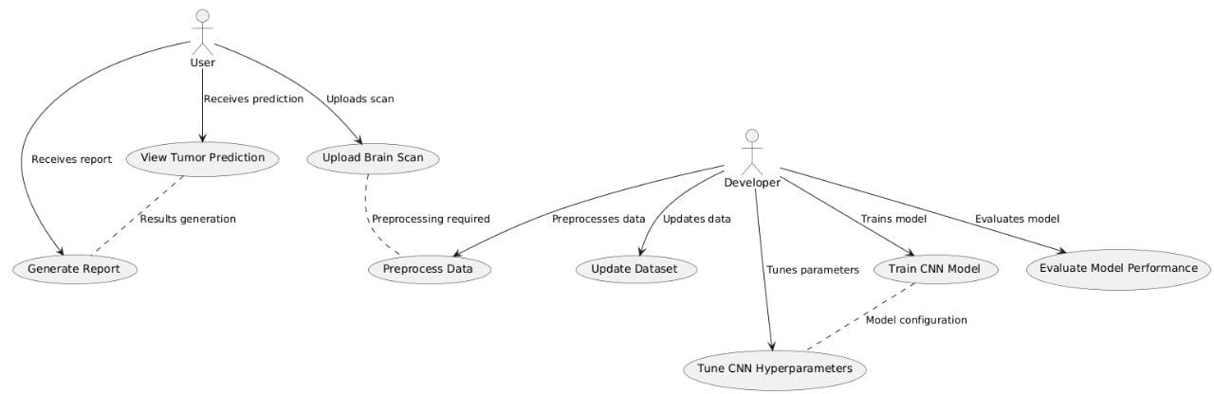
4.2.2 Use case Diagram
Actors:
- User-An individual who uploads brain scans and views tumor predictions.
- Developer-A person responsible for tuning, training, and evaluating the model for brain tumor detection.

Use Cases:
1. View Tumor Prediction (User) – The user uploads a brain scan and views the tumor prediction.
2. Upload Brain Scan (User) – The user uploads a scan for tumor detection.
3. Generate Report (User)– The user generates a report after viewing the prediction.
4. Preprocess Data (User/Developer) – Preprocessing is done on scans before analysis or model updates.
5. Update Dataset (Developer)– The developer updates the dataset with new scans or annotations.
6. Tune CNN Hyperparameters (Developer) – The developer adjusts CNN hyperparameters to improve performance.
7. Train CNN Model (Developer)– The developer trains the CNN model using updated data.
8. Evaluate Model Performance (Developer) – The developer assesses the model’s accuracy in tumor detection.
Interactions:
1. User uploads a scan → Preprocess Data.
2. User views prediction → Generate Report.
3. Developer preprocesses data → Update Dataset.
4. Developer tunes and trains the CNN model → Evaluate Performance.

3.SEQUENCE DIAGRAM
A sequence diagram is a Unified Modeling Language (UML) diagram that illustrates the sequence of messages between objects in an interaction. A sequence diagram consists of a group of objects that are represented by lifelines and the messages that they exchange over time during the interaction. A sequence diagram shows the sequence of messages passed between objects. Sequence diagrams can also show the control structures between objects. It is used to represent the flow of messages, events and actions between the objects or components of the system. Time is represented in the vertical direction showing the sequence of interactions of the header elements, which are displayed horizontally at the top of the diagram.
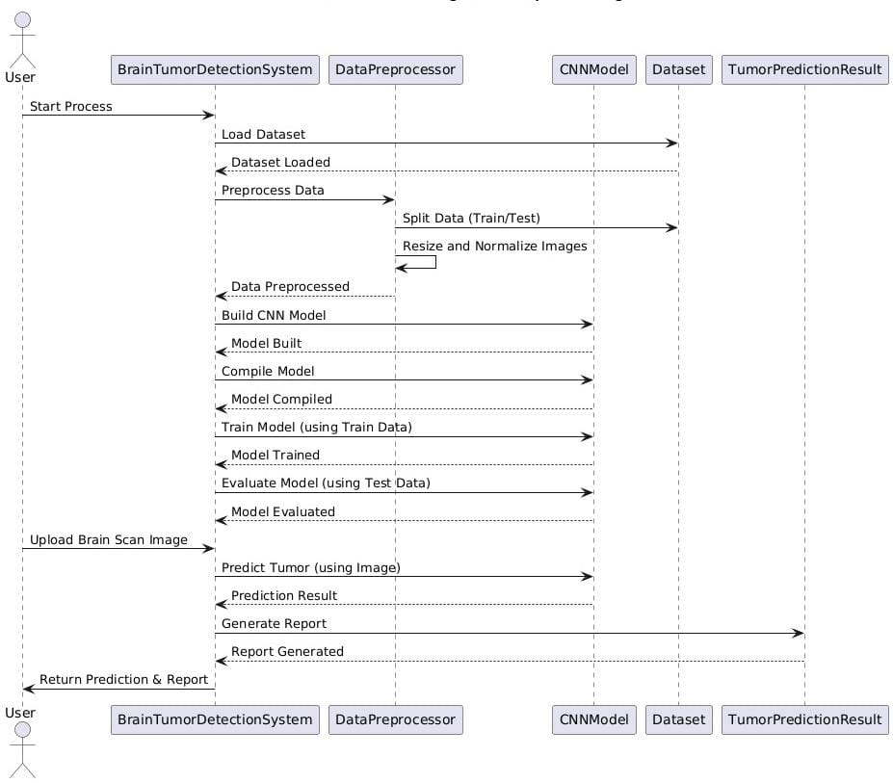

    - Sequence Diagram
Participants:
- User - The person interacting with the system.
- BrainTumorDetectionSystem - The main system managing the workflow of brain tumor detection.
- DataPreprocessor - Component responsible for preprocessing the dataset.
- CNNModel - The convolutional neural network model built for detecting tumors.
- Dataset - The dataset containing brain scans used for training and evaluation.
- TumorPredictionResult - Handles the result generation and report for tumor prediction.
Interactions:
1. User -> BrainTumorDetectionSystem: The user starts the brain tumor detection process.
2. BrainTumorDetectionSystem -> Dataset: The system loads the dataset.
3. Dataset -> BrainTumorDetectionSystem: The dataset is successfully loaded.
4. BrainTumorDetectionSystem -> DataPreprocessor: The system sends the data for preprocessing.
5. DataPreprocessor -> Dataset: The data is split into training and testing sets.
6. DataPreprocessor -> Dataset: The images are resized and normalized.
7. Dataset -> DataPreprocessor: The data preprocessing is completed.
8. DataPreprocessor -> BrainTumorDetectionSystem: The system is notified that the data preprocessing is done.
9. BrainTumorDetectionSystem -> CNNModel: The system requests the CNN model to be built.
10. CNNModel -> BrainTumorDetectionSystem: The CNN model is successfully built.
11. BrainTumorDetectionSystem -> CNNModel: The system compiles the CNN model.
12. CNNModel -> BrainTumorDetectionSystem: The model compilation is completed.
13. BrainTumorDetectionSystem -> CNNModel: The system trains the model using the training data.
14. CNNModel -> BrainTumorDetectionSystem: The model is trained successfully.
15. BrainTumorDetectionSystem -> CNNModel: The system evaluates the model using the test data.
16. CNNModel -> BrainTumorDetectionSystem: The model evaluation is completed.
17. User -> BrainTumorDetectionSystem: The user uploads a brain scan image.
18. BrainTumorDetectionSystem -> CNNModel: The system predicts a tumor using the uploaded image.
19. CNNModel -> TumorPredictionResult: The tumor prediction result is generated.
20. TumorPredictionResult -> BrainTumorDetectionSystem: The system generates a report based on the prediction.
21. BrainTumorDetectionSystem -> User: The system returns the tumor prediction and report to the user.

4.ACTIVITY DIAGRAM
An activity diagram is a type of Unified Modeling Language (UML) flowchart that shows the flow from one activity to another in a system or process. It's used to describe the different dynamic aspects of a system and is referred to as a 'behavior diagram' because it describes what should happen in the modeled system. It represents the business and operational workflows of a system. It is a dynamic diagram that shows the activity and event that causes the object to be in the particular state.
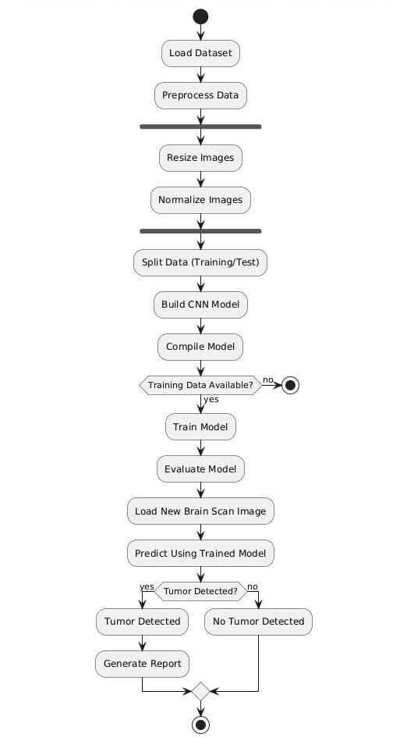

    - Activity Diagram
Activities:
1. Load Dataset - The system starts by loading the dataset containing brain scan images.
2. Preprocess Data-The dataset is preprocessed for further use.
3. Resize Images-Images are resized to a uniform dimension suitable for the CNN model.
4. Normalize Images-The pixel values of the images are normalized.
5. Split Data (Training/Test)-The data is split into training and testing datasets.
6. Build CNN Model- A Convolutional Neural Network (CNN) model is built for brain tumor detection.
7. Compile Model-The CNN model is compiled for training.
8. Check if Training Data Available- A decision is made based on whether training data is available:
- If "No," the process terminates.
- If "Yes," proceed to the next step.
9. Train Model-The CNN model is trained using the training data.
10. Evaluate Model-The trained CNN model is evaluated using the test data.
11. Load New Brain Scan Image- A new brain scan image is uploaded for tumor prediction.
12. Predict Using Trained Model-The trained CNN model predicts whether a tumor is present in the new image.
13. Tumor Detected? -A decision point:
- If "Yes," proceed to "Tumor Detected."
- If "No," proceed to "No Tumor Detected."
14. Tumor Detected- The system indicates that a tumor has been detected.
15. No Tumor Detected- The system indicates that no tumor has been detected.
16. Generate Report- A report is generated based on the prediction results.
This sequence outlines the steps in the brain tumor detection process using the CNN model.

CHAPTER 5
METHODOLOGY
5.1 TECHNOLOGIES USED
- Python Language:
Python language is a high-level, dynamically typed one that is among the most popular general-purpose programming languages. Python is an Interpreted, object-oriented, and high- level programming language. It is called an interpreted language as its source code is compiled to bytecode which is then interpreted. Python’s features, among other things, are what make it popular. For instance, it supports dynamic typing and dynamic binding.
Features of Python:
  - Python is open source. You can download it for free and use it in your application. You can also read and modify the source code.
  - The Python framework also has modules and packages, which facilitates code reusability.
  - It provides rich data types and easier to read syntax than any other programming languages
  - It is a platform independent scripted language with full access to operating system API's
  - Compared to other programming languages, it allows more run-time flexibility.
  - It includes the basic text manipulation facilities of Perl and Awk
  - A module in Python may have one or more classes and free functions
  - Libraries in Pythons are cross-platform compatible with Linux, Macintosh, and Windows
  - For building large applications, Python can be compiled to byte-code.
  - Python supports functional and structured programming as well as OOP
  - It supports interactive mode that allows interacting Testing and debugging of snippets of code
  - Python boasts a vast ecosystem of third-party libraries and frameworks. These libraries and frameworks provide developers with access to pre-built code and functionalities, reducing development time and increasing productivity.
  - The active and friendly nature of the Python community makes it an ideal environment for both beginners and experienced developers. Beginners can seek guidance and assistance, while experienced developers can engage in discussions, share insights, and collaborate on open-source projects. The strong community support fosters learning, mentoring, and problem-solving, making Python a favorable choice for developers seeking growth and support.
  - In Python, since there is no compilation step, editing, debugging and testing is fast.
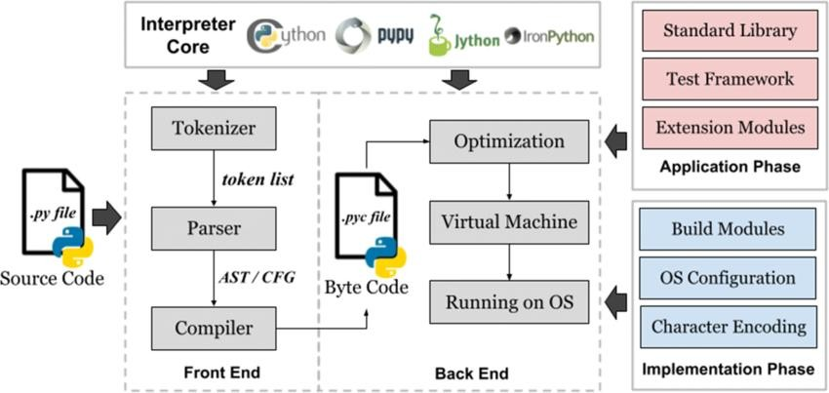
FIG 5.1.1 Architecture of Python
2.Machine Learning:
Definition: Machine learning (ML) is a subset of artificial intelligence (AI) that enables computers to learn from data and make decisions or predictions without being explicitly programmed. ML algorithms identify patterns in data and improve their performance over time based on experience.
How It Works:
- Data-Driven: Machine learning relies on large datasets to train models. The models learn from the data by identifying relationships and patterns.
- Types of Learning:
  - Supervised Learning: The model is trained on a labeled dataset, meaning the input data is paired with the correct output. The model learns to map inputs to outputs and make predictions on new data.
  - Unsupervised Learning: The model is trained on unlabeled data and must find hidden patterns or intrinsic structures in the input data. Clustering and dimensionality reduction are common techniques in this category.
  - Reinforcement Learning: The model learns by interacting with an environment and receiving feedback in the form of rewards or penalties. It aims to maximize cumulative rewards by learning optimal strategies.
Applications:
- Image Recognition: Identifying objects in images, such as in facial recognition systems or medical image analysis.
- Natural Language Processing (NLP): Enabling machines to understand and respond to human language, as seen in chatbots and translation services.
- Recommendation Systems: Suggesting products or content based on user preferences and behavior, widely used by platforms like Netflix and Amazon.
- Fraud Detection: Analyzing transaction patterns to identify and prevent fraudulent activities in finance.
Training Process:
- Feature Extraction: In traditional ML, features are often manually engineered. Features are the individual measurable properties or characteristics used as input for the model.
- Model Training: The model is trained using algorithms that optimize its parameters based on the data, adjusting to minimize prediction errors.
- Evaluation: The model's performance is evaluated using metrics like accuracy, precision, recall, and F1 score on a separate validation dataset.
Neural Networks: While traditional ML algorithms (e.g., decision trees, support vector machines) can handle various tasks, neural networks are a class of ML models inspired by the structure of the human brain. They consist of interconnected nodes (neurons) organized in layers, enabling them to learn complex patterns in data.

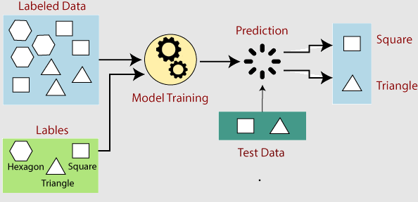
Fig. 5.1.2 Working of Machine Learning
3.Keras:
There are many libraries that support deep learning, such as Theano, TensorFlow, Caffe, MxNet, and others. Keras is one of the most powerful and user-friendly Python libraries, and it is built on top of well-known deep learning libraries like TensorFlow, Theano, etc.
TensorFlow, Theano, or the Cognitive Toolkit are a few examples of opensource machine libraries on top of which Keras is built (CNTK). A Python package called Theano is used for quick numerical computing jobs. For building neural networks and deep learning models, TensorFlow is the most well-known symbolic math library. Distributed computing is the main advantage of TensorFlow, which is incredibly adaptable. The deep learning framework CNTK was created by Microsoft. It makes use of standalone machine learning toolkits or libraries written in Python, C#, or C++. For building neural networks, Theano and TensorFlow are extremely powerful libraries but also challenging to learn. The basic structure of Keras makes it simple and quick to build TensorFlow or Theano-based deep learning models. Deep learning models may be quickly defined with Keras. Well, Keras is the best option for applications requiring deep learning.
The Sequential constructor takes an array of Keras Layers. We’ll use 3 types of layers for our CNN: Convolutional, Max Pooling, and Softmax.
4.TensorFlow:
TensorFlow is an open-source machine learning library developed by Google that is widely used for building and deploying deep learning models. It provides a flexible and comprehensive ecosystem for numerical computation, enabling developers to create complex machine learning algorithms with ease. TensorFlow supports both high-level APIs, such as Keras, for quick model building, and low-level APIs for more granular control over computations. Its core feature is the ability to define and execute computation graphs, allowing for efficient optimization and resource management during model training. TensorFlow excels in scalability, enabling the deployment of models across various platforms, including mobile devices and cloud services. Its rich ecosystem includes tools for visualization (TensorBoard), model serving (TensorFlow Serving), and mobile deployment (TensorFlow Lite), making it a preferred choice for both research and production applications in machine learning. TensorFlow is a powerful open-source library for machine learning and deep learning developed by Google. It is designed to facilitate the building and training of complex neural networks through a flexible architecture that allows developers to create computation graphs. This graph-based approach enables TensorFlow to efficiently perform parallel processing and optimize resource utilization, making it suitable for both small-scale and large-scale machine learning tasks. The library supports multiple programming languages, including Python, C++, and JavaScript, making it accessible to a wide range of developers. With its high-level APIs, such as Keras, TensorFlow simplifies the process of designing and deploying deep learning models. It offers an extensive ecosystem of tools and libraries for tasks like data preprocessing, model training, evaluation, and deployment. TensorFlow also provides support for distributed computing, allowing users to train models across multiple GPUs or TPU (Tensor Processing Unit) clusters. This capability makes it an ideal choice for both researchers exploring new algorithms and industry practitioners developing production-ready machine learning solutions.
5.Flask:
Flask is a lightweight and flexible web framework for Python that facilitates the rapid development of web applications. As a microframework, it provides the essential tools required to build web applications without imposing any specific project structure or dependencies, allowing developers to choose their libraries and tools based on their project's needs. Flask's key features include simplicity, modularity, and extensibility, enabling developers to create well-organized applications that are easy to maintain. The framework uses a routing system that maps URLs to Python functions, making it straightforward to handle HTTP requests and responses. Additionally, Flask integrates with the Jinja2 templating engine, allowing for the separation of application logic from the presentation layer, thereby enabling the generation of dynamic HTML content.
Flask also supports advanced features like custom error handling, configuration management, and the creation of blueprints for better code organization in larger applications. It is widely used for building web applications, RESTful APIs, and data visualization tools, making it an excellent choice for both rapid prototyping and production-ready applications. Its built-in development server, along with support for unit testing, ensures that developers can efficiently test and refine their applications throughout the development process. This flexibility allows developers to tailor their applications to specific requirements, making Flask a versatile option for various project needs.
6.HTML/CSS:
HTML (Hypertext Markup Language) serves as the foundational standard for creating web pages, defining the structure and content of a website. It utilizes a system of tags and elements to organize various components such as headings, paragraphs, links, images, and forms. HTML is essential for laying out the content of a webpage, allowing developers to create structured documents that can be rendered by web browsers. In the context of a Flask application, HTML templates such as `upload.html` and `complete.html` are dynamically generated and rendered by the Flask framework, enabling the seamless display of information and interactive elements to users. These templates play a crucial role in creating a user-friendly interface, as they allow developers to define how the content is presented and how users interact with the application.
CSS (Cascading Style Sheets) complements HTML by providing the styling and layout for web pages. While HTML outlines the structure of the content, CSS is responsible for enhancing the visual presentation, including colors, fonts, spacing, and overall layout design. In a Flask application, CSS is typically linked within the HTML templates to ensure consistent styling across different pages. By improving the visual aesthetics and user experience, CSS plays a vital role in making web applications more appealing and intuitive. Together, HTML and CSS form the backbone of web development, allowing developers to create responsive, interactive, and visually engaging applications that cater to user needs.
7.NUMPY
NumPy is a popular Python library that simplifies working with numbers and performing mathematical operations. It serves as a powerful tool for efficiently handling large groups of numbers, such as lists or tables. The core feature of NumPy is the array, which is similar to a Python list but much more powerful. Arrays can be one-dimensional (like a list) or multi-dimensional (like a table or a 3D grid). One of the advantages of NumPy is its speed; NumPy arrays are faster than regular Python lists because they are stored more efficiently in memory, allowing for quick calculations on large datasets. Additionally, NumPy provides a variety of built-in functions to perform mathematical operations (such as addition, subtraction, multiplication, and division) on entire arrays at once, eliminating the need to loop through each element. It also offers easy ways to reshape, filter, and manipulate arrays, making it ideal for tasks related to data analysis and scientific computing.

5.2 MODULES DESCRIPTION
1.OS Module: The OS module in Python provides a way to interact with the operating system. It is particularly useful for tasks like managing files and directories, accessing system environment variables, and handling file paths.
- In this project, the OS module is used to manage the directory where uploaded images are stored.
- os.path.dirname(os.path.abspath(__file__)) is used to find the directory where the script is running, setting a base path (APP_ROOT) for file storage.
- os.path.join() combines different parts of the file path, creating a target path that points to an image’s directory. This method ensures compatibility across different operating systems.
- os.path.isdir() checks if the images directory already exists. If the directory does not exist, os.mkdir() is used to create it, ensuring there is a designated location for saving uploaded files.

2.Flask Modules: The Flask modules play a vital role in building and running the web application in Python.
- The Flask class is the core component for creating and setting up a web application.
- By initializing an instance (app = Flask(__name__)), the app can define routes (URL endpoints) and handle different functions.
- The app uses the initialized Flask instance to set up routes, specifying how it should respond to various requests from users (e.g., serving web pages, handling form submissions).
- The render_template function allows the app to render HTML templates, serving dynamic content to users by displaying HTML files in the browser. This separation of front-end (HTML) and back-end logic makes the code cleaner and easier to manage.
- The request module handles incoming HTTP requests, such as file uploads from users. It enables the app to receive data from forms submitted by users, process the data (like saving files), and respond appropriately.

3.TensorFlow & Keras Modules: The TensorFlow & Keras modules are used to handle the machine learning aspects of the application, specifically loading a pre-trained model, preprocessing images, and performing predictions.
- The tensorflow.keras.models.load_model function is used to load a pre-trained deep learning model ("VGG_model.h5"). This allows the application to make predictions on new data without the need for retraining, enabling quick and efficient analysis.
- The tensorflow.keras.preprocessing.image module handles image preprocessing, including resizing, converting images to arrays, and normalizing pixel values. This ensures that images are in the correct format for the model, making them ready for analysis.
- NumPy is used for numerical operations, such as converting images to arrays and reshaping them. These operations prepare the image data in a way that the model can easily process during predictions.
- The tensorflow.keras.optimizers.Adam is imported but not used in the code. This optimizer is typically applied during model training, suggesting it may have been intended for training or fine-tuning in other parts of the project.

CHAPTER 6
IMPLEMENTATION
6.1 SAMPLE CODE
app.py:
import os
from flask import Flask, render_template, request
from predictor import check
author = 'TEAM DELTA'
app = Flask (__name__, static_folder="images")
APP_ROOT = os.path.dirname(os.path.abspath(__file__))
@app.route('/')
@app.route('/index')
def index():
return render_template('upload.html')
@app.route('/upload', methods= ['GET', 'POST'])
def upload():
target = os.path.join(APP_ROOT, 'images/')
print(target)
if not os.path.isdir(target):
os.mkdir(target)
for file in request.files.getlist('file'):
print(file)
filename = file.filename
print(filename)
dest = '/'.join([target, filename])
print(dest)
file.save(dest)
status = check(filename)
return render_template('complete.html', image_name=filename, predvalue=status)
if __name__ == "main":
app.run(port=4555, debug=True)
predictor.py:
import numpy as np
import tensorflow as tf
from tensorflow import keras
from keras.preprocessing import image
from tensorflow.keras.preprocessing import image
from tensorflow.keras.models import load_model
from tensorflow.keras.optimizers import Adam
from keras.preprocessing import image
from tensorflow.keras.models import load_model
saved_model =load_model("model/VGG_model.h5", compile=False)
status = True
def check(input_img):
print(" your image is: " + input_img)
print(input_img)
img = image.load_img ("images/" + input_img, target_size= (224, 224))
img = np.asarray(img)
print(img)
img = np.expand_dims(img, axis=0)
print(img)
output = saved_model.predict(img)
print(output)
if output [0][0] == 1:
status = True
else:
status = False
print(status)
return status
complete.html:
<!doctype html>
<html lang="en">
<head>
<meta charset="UTF-8">
<meta name="viewport" content="width=device-width, user-scalable=no, initial-scale=1.0, maximum-scale=1.0, minimum-scale=1.0">
<meta http-equiv="X-UA-Compatible" content="ie=edge"><title>Brain Tumor Detection</title>
<link type="text/css" href="{{ url_for('static', filename='css/bootstrap.min.css') }}" rel="stylesheet" />
<link rel="stylesheet" href="https://stackpath.bootstrapcdn.com/bootstrap/4.4.1/css/bootstrap.min.css" integrity="sha384-Vkoo8x4CGsO3+Hhxv8T/Q5PaXtkKtu6ug5TOeNV6gBiFeWPGFN9MuhOf23Q9Ifjh" crossorigin="anonymous">
</head>
<body class="bg-light">
<nav class="navbar navbar-expand-lg navbar-dark bg-primary">
<a class="navbar-brand" href="#">Brain Tumor Detection</a>
<button class="navbar-toggler" type="button" data-toggle="collapse" data-target="#navbarSupportedContent" aria-controls="navbarSupportedContent" aria-expanded="false" aria-label="Toggle navigation">
<span class="navbar-toggler-icon"></span>
</button>
<div class="collapse navbar-collapse" id="navbarSupportedContent">
<ul class="navbar-nav ml-auto">
<li class="nav-item active">
<a class="nav-link" href="./">Home <span class="sr-only">(current)</span></a>
</li>
</ul>
</div>
</nav>
<div class="container">
<h3 class="text-center display-3 mt-3 mb-3">Result</h3>
<img src="../images/{{ image_name }}" height="300px" class="image-responsive align-center" style="display: block; margin-left: auto; margin-right: auto; width: 25%;">
{% if predvalue %}
<h4 class="text-left display-5 text-center pt-3">Result: <span style="color:red;">Brain Tumor detected!!!</span></h4> {% else %}
<h4 class="text-left display-5 text-center pt-3">Result: <span style="color:green;">No Brain Tumor</span></h4> {% endif %}
</div>
<script src="https://code.jquery.com/jquery-3.4.1.slim.min.js" integrity="sha384-J6qa4849blE2+poT4WnyKhv5vZF5SrPo0iEjwBvKU7imGFAV0wwj1yYfoRSJoZ+n" crossorigin="anonymous"></script>
<script src="https://cdn.jsdelivr.net/npm/popper.js@1.16.0/dist/umd/popper.min.js" integrity="sha384-Q6E9RHvbIyZFJoft+2mJbHaEWldlvI9IOYy5n3zV9zzTtmI3UksdQRVvoxMfooAo" crossorigin="anonymous"></script>
<script src="https://stackpath.bootstrapcdn.com/bootstrap/4.4.1/js/bootstrap.min.js" integrity="sha384-wfSDF2E50Y2D1uUdj0O3uMBJnjuUD4Ih7YwaYd1iqfktj0Uod8GCExl3Og8ifwB6" crossorigin="anonymous"></script>
</body>
</html>
upload.html:
<!doctype html>
<html lang="en">
<head>
<meta charset="UTF-8">
<meta name="viewport" content="width=device-width, user-scalable=no, initial-scale=1.0, maximum-scale=1.0, minimum-scale=1.0">
<meta http-equiv="X-UA-Compatible" content="ie=edge">
<title>Brain Tumor Detection</title>
<link type="text/css" href="{{url_for ('static', filename='css/bootstrap.min.css') }}" rel="stylesheet" />
<link rel="stylesheet" href="https://stackpath.bootstrapcdn.com/bootstrap/4.4.1/css/bootstrap.min.css" integrity="sha384-Vkoo8x4CGsO3+Hhxv8T/Q5PaXtkKtu6ug5TOeNV6gBiFeWPGFN9MuhOf23Q9Ifjh" crossorigin="anonymous">
</head>
<body class="bg-light">
<nav class="navbar navbar-expand-lg navbar-dark bg-primary">
<!-- <a class="navbar-brand" href="#">Cancer Predictor and Detector</a> -->
<a class="navbar-brand" href="#">Brain Tumor Detection</a>
<button class="navbar-toggler" type="button" data-toggle="collapse" data-target="#navbarSupportedContent" aria-controls="navbarSupportedContent" aria-expanded="false" aria-label="Toggle navigation">
<span class="navbar-toggler-icon"></span>
</button>
<div class="collapse navbar-collapse" id="navbarSupportedContent">
<ul class="navbar-nav ml-auto">
<li class="nav-item active">
<a class="nav-link" href="./">Home <span class="sr-only">(current)</span></a>
</li>
</ul>
</div>
</nav>
<script src="https://code.jquery.com/jquery-3.4.1.slim.min.js" integrity="sha384-J6qa4849blE2+poT4WnyKhv5vZF5SrPo0iEjwBvKU7imGFAV0wwj1yYfoRSJoZ+n" crossorigin="anonymous"></script>
<script src="https://cdn.jsdelivr.net/npm/popper.js@1.16.0/dist/umd/popper.min.js" integrity="sha384-Q6E9RHvbIyZFJoft+2mJbHaEWldlvI9IOYy5n3zV9zzTtmI3UksdQRVvoxMfooAo" crossorigin="anonymous"></script>
<script src="https://stackpath.bootstrapcdn.com/bootstrap/4.4.1/js/bootstrap.min.js" integrity="sha384-wfSDF2E50Y2D1uUdj0O3uMBJnjuUD4Ih7YwaYd1iqfktj0Uod8GCExl3Og8ifwB6" crossorigin="anonymous"></script>
</body>
</html>

<div class="container mt-auto" style="padding-top: 10%;">
<form id="upload-form" action="{{ url_for('upload') }}" method="post" enctype="multipart/form-data">
<div class="row mt-5">
<div class="col-md-2"></div>
<div class="col-md-8 justify-content-center center">
<h3 class="display-5 text-center">Upload MRI image of Brain: </h3>
<!-- <input id="file-picker" type="file" name="file" accept="image/*" multiple> --> <input id="file-picker" type="file" name="file" accept="image/*" class="file-control col-md-6 d-flex justify-content-center" style="display: block; margin-left: auto; margin-right: auto; width: 40%;" required>
<div id="msg"></div>
<div class="mt-5">
<button type="submit" class="btn btn-primary btn-lg btn-block col-md-8 mr-auto ml-auto" id="upload-button">Check Tumor Status</button>
</div>
</form>
</div>
<div class="col-md-2"></div>
</div>
</div>
<script src="https://code.jquery.com/jquery-3.4.1.slim.min.js" integrity="sha384-J6qa4849blE2+poT4WnyKhv5vZF5SrPo0iEjwBvKU7imGFAV0wwj1yYfoRSJoZ+n" crossorigin="anonymous"></script>
<script src="https://cdn.jsdelivr.net/npm/popper.js@1.16.0/dist/umd/popper.min.js" integrity="sha384-Q6E9RHvbIyZFJoft+2mJbHaEWldlvI9IOYy5n3zV9zzTtmI3UksdQRVvoxMfooAo" crossorigin="anonymous"></script>
</body>
</html>

6.2 OUTPUT SCREENS
OUTPUT OF HOME PAGE FOR UPLOADING IMAGES:
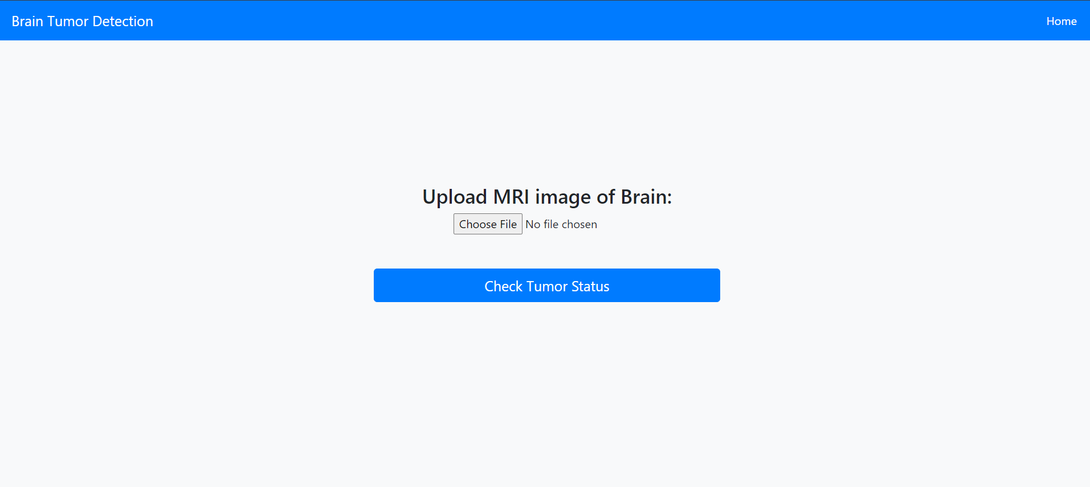

OUPTUT OF CHOOSING IMAGES:
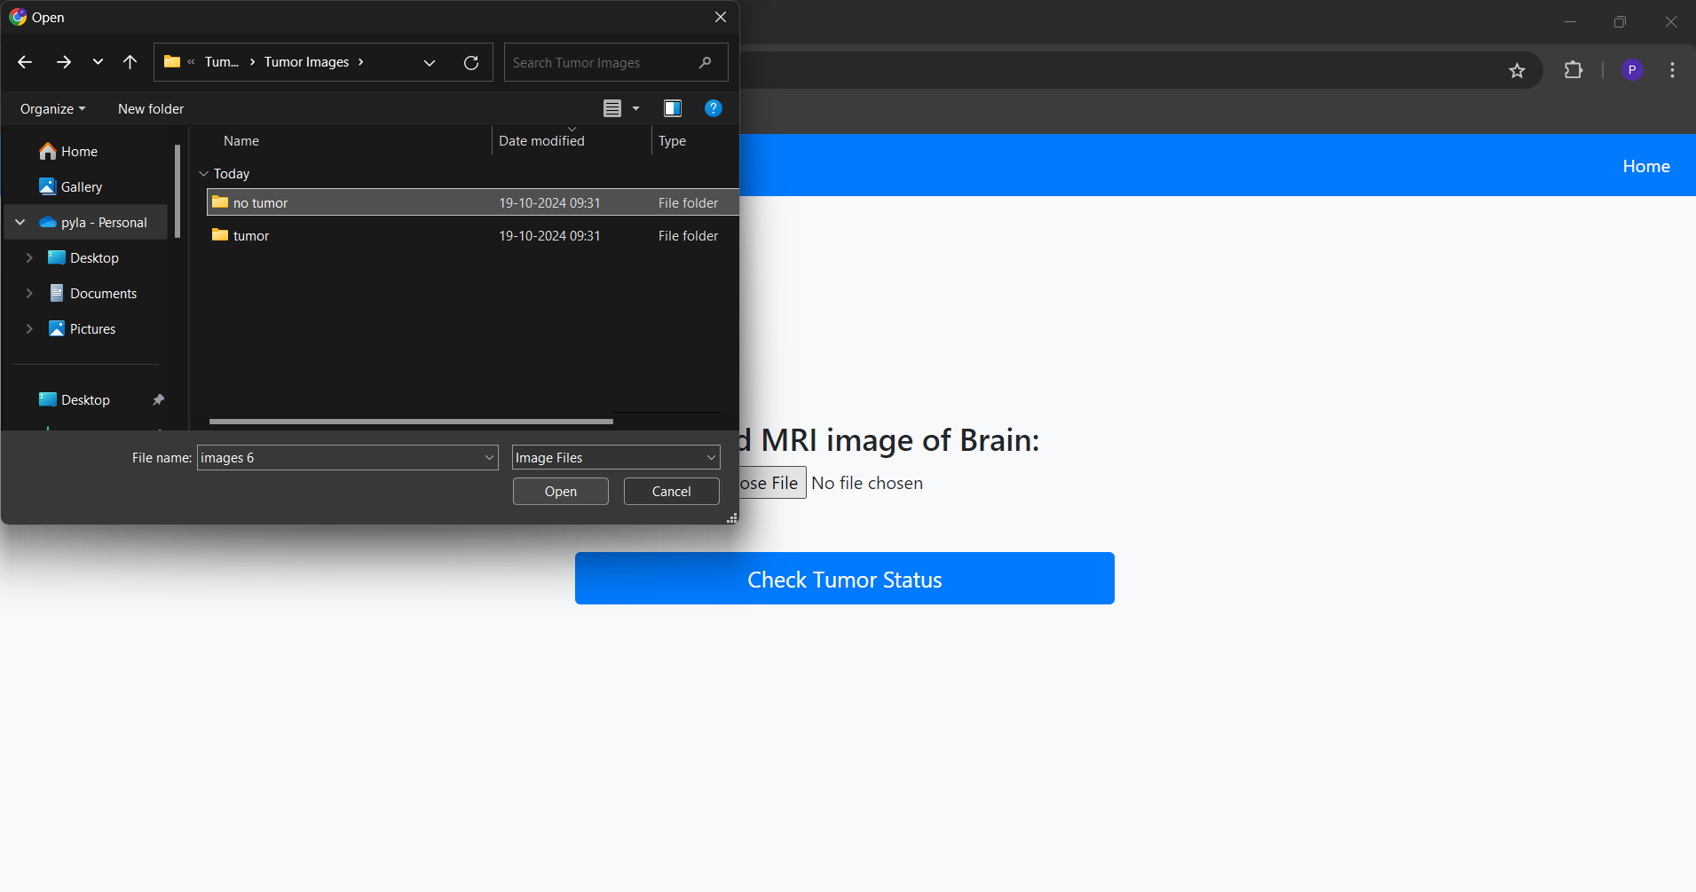

OUTPUT OF BRAIN TUMOR DETECTION:
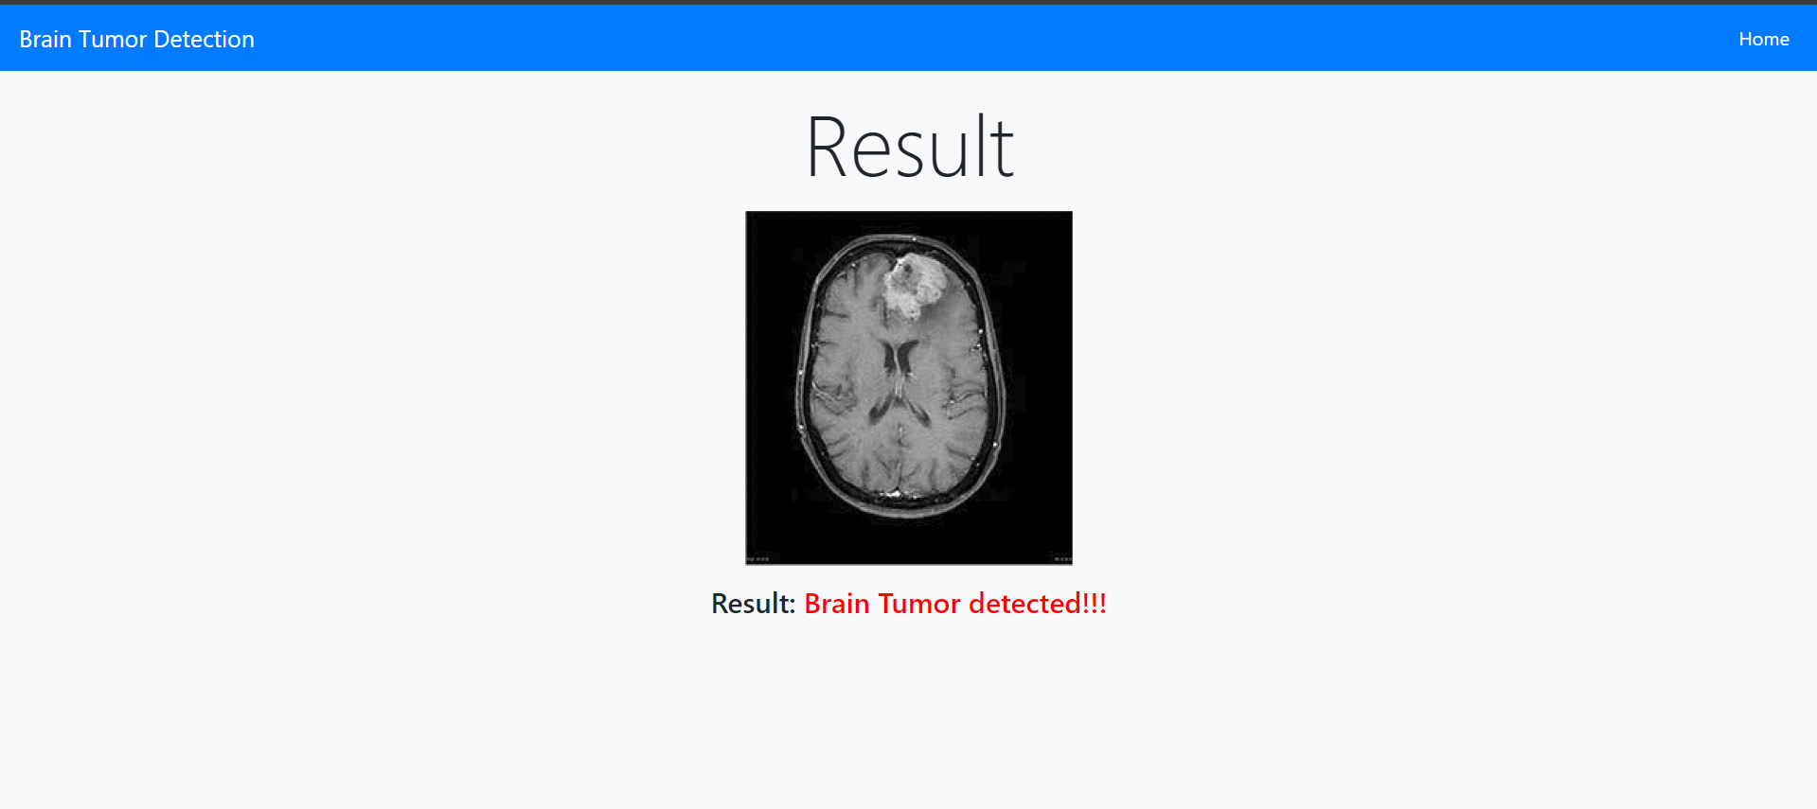

OUTPUT OF NO BRAIN TUMOR DETECTION:
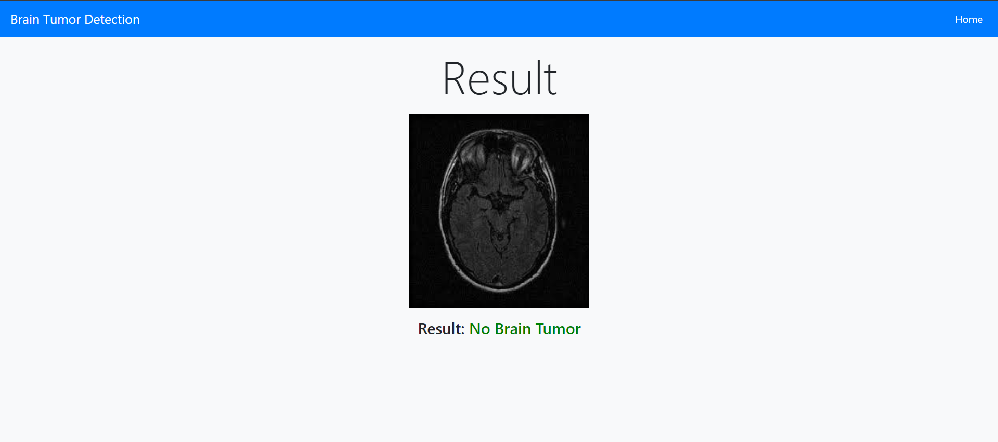

CHAPTER 7
CONCLUSION & FUTURE SCOPE
CONCLUSION
Brain tumor detection using machine learning represents a remarkable convergence of medical science and technology, offering new possibilities in early diagnosis and treatment. Advanced techniques, particularly convolutional neural networks (CNNs), have proven to be effective tools for accurately identifying and classifying brain tumors from medical imaging. This technological advancement not only enhances diagnostic accuracy but also improves the speed and efficiency of the detection process, leading to timely medical interventions that can potentially save lives.
The use of machine learning in brain tumor detection addresses challenges such as misdiagnosis and the need for extensive manual analysis by medical professionals. By training models on large datasets of brain scans, machine learning algorithms can learn to recognize patterns and abnormalities, providing a more precise analysis than traditional methods. This can lead to improved patient outcomes, as doctors are equipped with reliable tools to identify tumors at earlier stages.
While the technology is promising, it is important to recognize that machine learning models must be developed and deployed responsibly. Ensuring the ethical use of patient data, maintaining accuracy across diverse populations, and integrating machine learning systems seamlessly into clinical workflows are crucial considerations. As the field of machine learning advances, it is essential to approach brain tumor detection with a focus on reliability, transparency, and patient safety.
Essentially, the integration of machine learning into brain tumor detection offers a future where advanced technology assists healthcare professionals in making more informed decisions, leading to better patient care and potentially higher survival rates.
FUTURE SCOPE
The future scope of brain tumor detection using machine learning is vast and holds immense potential for revolutionizing the field of medical diagnostics. With continuous advancements in machine learning algorithms, especially in deep learning and image processing, researchers can develop even more sophisticated models capable of detecting tumors with higher accuracy and at earlier stages. This could lead to the creation of automated diagnostic systems that assist radiologists, reducing the workload and ensuring more consistent and precise analysis.
Further developments in machine learning models may include the ability to not only detect tumors but also predict their growth and response to various treatments, enabling personalized treatment plans for patients. Integrating these models with other medical data, such as genetic information, could lead to comprehensive diagnostic solutions that offer deeper insights into a patient’s condition.
Moreover, as machine learning models become more accurate and robust, they could be deployed across healthcare systems worldwide, including in regions with limited access to specialized medical care. This would democratize access to advanced diagnostic tools, ensuring that more patients can benefit from early and accurate detection of brain tumors.
The commercial and healthcare industries stand to gain significantly from this technology. Pharmaceutical companies can use machine learning for drug discovery, testing how new drugs might affect different tumor types. Hospitals and medical centers can integrate AI-powered diagnostic tools into their existing systems to enhance efficiency. Additionally, this technology could pave the way for real-time diagnostic applications, enabling doctors to make faster and more informed decisions during patient consultations.

Looking forward, integrating machine learning models with wearable health monitoring devices could enable continuous patient monitoring, especially for those at higher risk of developing brain tumors. This integration could lead to earlier detection of abnormalities, prompt follow-up checks, and more accurate tracking of a tumor’s progression or response to treatment, allowing for better patient management. Such advancements could contribute to proactive healthcare, reducing the time between diagnosis and intervention, and ultimately improving survival rates.
Collaborations between medical professionals, data scientists, and technologists will be key in pushing the boundaries of what machine learning can achieve in the field of brain tumor detection. As the technology evolves, it holds the promise of becoming an indispensable tool for medical diagnostics, paving the way for a future where machine learning not only aids in detecting brain tumors but also contributes to more personalized, precise, and proactive healthcare solutions. In essence, the future of brain tumor detection using machine learning is poised to transform the landscape of medical diagnostics, offering hope for improved patient outcomes and a more efficient healthcare system.

CHAPTER 8
BIBILOGRAPHY
[1] L. Kapoor and S. Thakur, “A comprehensive survey on brain tumor detection using image processing techniques,” IEEE 7th International Conference on Cloud Computing, Data Science & Engineering, vol. 5, no. 2, pp. 101–110, 2020.
[2] P. Gamage, “Identification of brain tumors using image processing techniques,” ResearchGate, vol. 3, no. 1, pp. 88–95, 2020.
[3] Deepa and A. Singh, “Recent advancements in brain tumor detection and segmentation from MRI images,” IEEE International Conference on Computing for Sustainable Global Development, vol. 8, no. 4, pp. 220–228, 2020.
[4] W. Shen, “Automatic detection of brain tumors using deep learning techniques,” IEEE Transactions on Medical Imaging, vol. 39, no. 6, pp. 200–210, 2020.
[5] S. Saxena, “A hybrid method for brain tumor classification using k-means clustering and support vector machines (SVM),” Journal of Biomedical Engineering, vol. 28, no. 4, pp. 456–467, 2020.
[6] M. S. Hossain, “Brain tumor segmentation and detection using U-Net variants,” IEEE Access, vol. 8, pp. 125020–125030, 2020.
[7] X. Zhao, “3D CNN for detecting and classifying brain tumors from MRI scans,” Neurocomputing, vol. 388, pp. 68–75, 2020.
[8] Z. Akkus, “A comprehensive review of machine learning methods for brain tumor segmentation,” Medical Image Analysis, vol. 60, pp. 101-110, 2020.
[9] Al-Jawad, “Review on convolutional neural networks (CNN) for brain tumor detection,” International Journal of Imaging Systems and Technology, vol. 30, no. 2, pp. 232–240, 2020.
[10] G. Quellec, “BRAMSIT MRI database: A comprehensive set of benign and malignant brain tumors,” IEEE Transactions on Medical Data Science, vol. 5, no. 3, pp. 135–140, 2020.

